Nama : Fikri Zaki Haiqal

NIM : L200170079

Modul : IV

Object Tanah

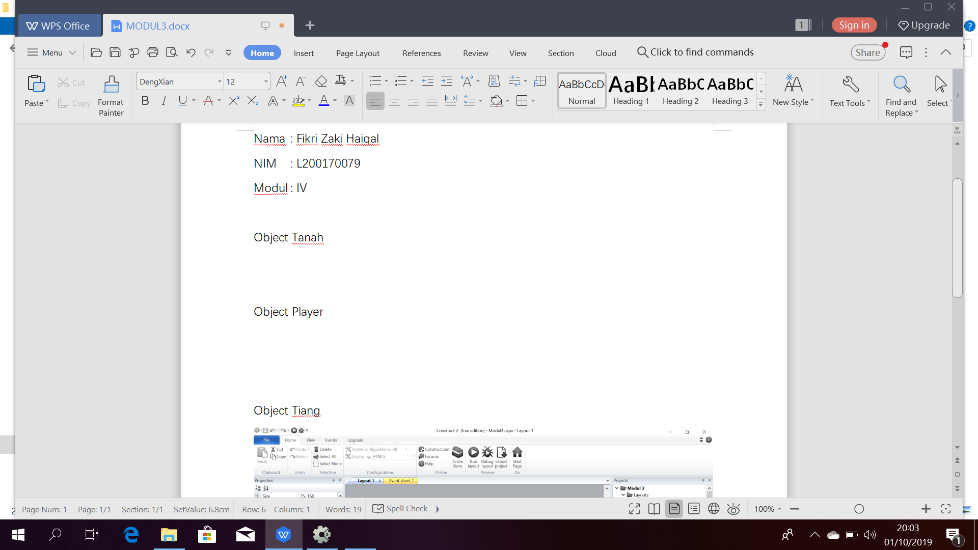

Object Player



Object Tiang

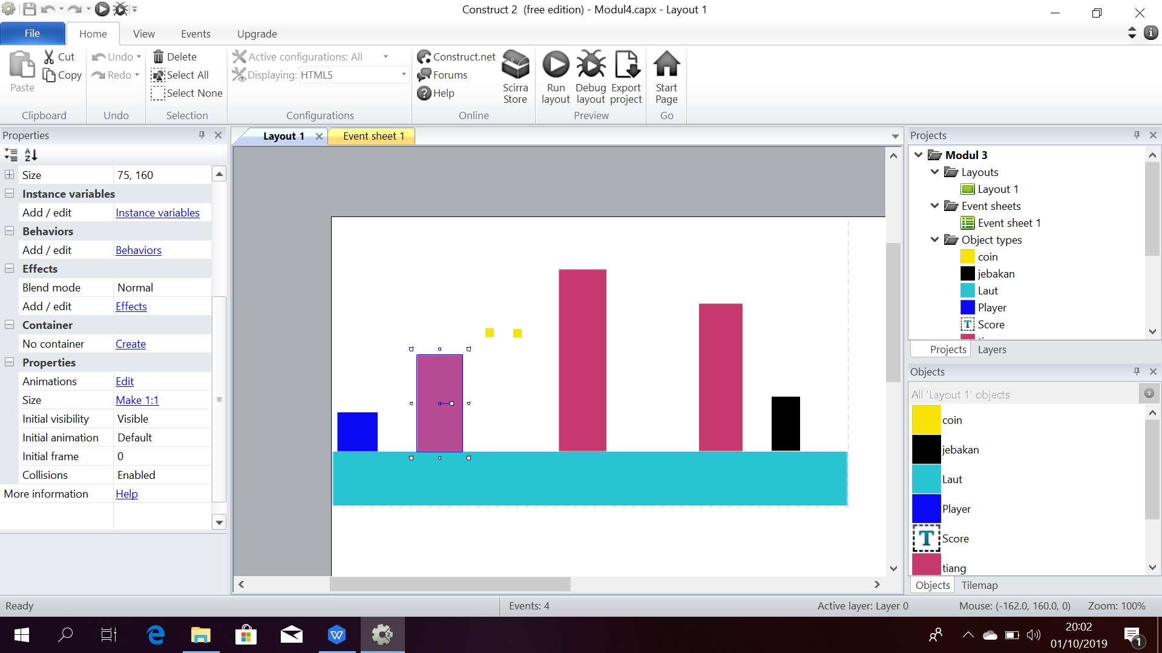

Object Coin

